Advice In Understanding & Measuring
Enhancing Service KPI’s Productivity & Efficiency

Step by Step Advice In Understanding & Measuring
Service Department Productivity
Everyone talks about productivity and the need to be productive. But how do you measure productivity and what are the issues that impact productivity? This article addresses both of those issues.

Productivity impacts revenue, the labor cost of sales and profitability. Yet it’s a nebulous term to most companies and they fail to measure and monitor it. You must be able to measure something before you can make meaningful improvements. This holds true for productivity. Some computer systems provide excellent productivity reports that make this easy. Most do not. The following article examines several methods of measuring productivity. Pick whatever method you like. The important thing is to select a method that works for you and then monitor productivity regularly.
This article goes on to explore those issues that affect productivity. Therefore, it ties in very closely with other articles on this website including:
- Reducing Service Department Labor Cost to 22% of Service Sales or Less
- Reducing Service Department Parts Cost to 13% of Sales or Less
- Achieving $125,000 or More in Residential Service Revenue per Service Vehicle
- Step by Step to Building a Service Department Growth Plan
Productivity
Productivity at its simplest definition refers to the amount of work or output compared to the amount of labor consumed. Obviously the more productive a company is the more work that can be billed out for the labor expense used and the more profitable the company is. The less productive a company is the less amount of work that can be billed out and the less profitable the company is.
In regards to residential service, there are a number of ways that a manager can look at productivity. These include but are not limited to billable hours, revenue potential and actual revenue.
Efficiency Ratio
This productivity measurement compares the labor hours paid versus billable hours recovered on service invoices. Dividing hours billed by hours paid yields this ratio:
Hours Billed
Hours Paid = Efficiency Ratio

Find out the total hours paid to service technicians from the payroll department. If a technician works in both service and installation, only include the hours worked in service. Next, add all the hours billed out on service invoices. Be sure to include hours worked on service agreements and maintenance.
This ratio is usually easy to generate, particularly with time & material pricing. However, it does not tell the complete story. For example, suppose a company pays its technicians based on billable time. In other words, the company only pays the technician for time that’s actually billed out to customers. Let’s suppose technician only bills out 1,000 hours throughout the year; although there are approximately 2,000 available (without overtime). The technician’s efficiency ratio is 100% even though he/she has only billed out half the time available. The technician is only generating half the revenue he/she is capable of.
Labor Hours Billed Versus Labor Hours Available
This productivity measurement is a comparison of the amount of labor hours billed versus the amount of labor hours available.
Begin by determining the number of hours available. This step allows management to pinpoint exactly how many days and hours are available to be sold.
- Use the following formula to determine the workdays per year.
Total Days in Year - Total Days Off = Work Days per Year
To calculate the total days off in a year, add:
Weekend Hours
Holidays
Vacation
Paid Sick Days
TOTAL DAYS OFF

Then subtract from the total days in the year (365) to determine the number of workdays available. For example suppose the company gave the following days off:
Weekend Hours 104
Holidays 10
Vacation 10
Paid Sick Days 0
TOTAL DAYS OFF 124
Then:
Total Days In Year 365
Total Days Off 124
Total Days Available 241

- Next determine the total work hours available per year using the following formula:
Total Work Days x Hours per Day = Total Work Hours per Year
Using the previous example and assuming an 8-hour day:
241 Days Available x 8 Hours = 1928 Hours Available per Year
- Now multiply the total hours available per technicians by the number of service technicians to find out the total service department hours available. Using the previous example, let’s assume there are 6 service technicians.
1928 Hours per Tech x 6 Techs = 11,568 Total Hours Available
Now compare to the actual hours billed out to get a ratio of billed hours versus hours available. Using the previous example, suppose the service department billed out 8,097 hours. The ratio is:
Hours Billed 8,097
Hours Available 11,568 or 70%
Technicians should be able to bill out six hours out of an eight-hour day. This ratio is then 6/8 or 75%. The other 25% is for travel and unapplied time.
The ratio in the example was 70%. This indicates the service department is not billing out as many hours as it should and nor is as productive as it could be.
This measurement can be applied to individual technicians as well as the entire service department.
Revenue Potential Comparison
Neither of the billable hours methods discussed above consider the impact of part sales. In a time & material pricing environment, a technician could be spending his/her time trying to fix a part that should be replaced. Although the time on the call is being billed out, overall revenue is affected and there is a good probability of a callback or a need for a future service call. Neither of these possibilities is good from a customer relation’s standpoint.
Another method of monitoring productivity compares actual service sales to the potential revenue. There’s an industry benchmark that states for every dollar in service labor sales, there should be another dollar in parts sales. In other words, there should be a one to one relationship in labor and parts sales. Once you know the service sales potential, you can quickly determine the whole service department sales potential.
- Begin by determining the number of hours available. Refer to write up on pages 1 through 3.
- Determine the number of days off per year per technician.
- Determine the number of workdays per year per technician
- Determine the number of work hours available per technician.
- Determine the total number of work hours available to the service department per year.
- Determine the labor sales potential for the service department by multiplying the work hours available by the hourly retail rate. Using the previous example, suppose the hourly labor rate was $ 75 per hour.

Total Hours Available 11,568
Hourly Rate x $100.00
Total Labor Sales Potential $867,600

For six service technicians, this potential labor sales seems high, but the math speaks for itself. As mentioned previously, being able to bill six hours out of an eight hour day is a very reasonable rule-of-thumb. That correlates to 75%.

Total Labor Sales Potential $867,600
x 75%
$650,700

To find the total service department potential revenue, multiply the total labor sales potential by 2. This yields a 1-to-1 parts to labor sales ratio. Continuing on with the example:

Total Labor Sales $867,600
x 2
Total Service Department Potential $1,735,200

x 75%
Total Service Department Potential $1,301,400

Considering that the example had six service technicians, this averages to $216,900 per technician.

Revenue Potential at 75% $1,301,400 = $216,900
Number of Technicians 6

It’s good for management to look at its revenue potential now and then. The term revenue potential is also called theoretical production. The theoretical production calculations can help you analyze your service department’s capability versus its actual production in revenue. ‘Gaps’ should always be analyzed to see if there are ways to improve revenue performance.
There’s another Key Performance Indicator that says that the revenue per sales vehicle should be $125,000. Recognize that some companies exceed this benchmark of $125,000 per vehicle, but many companies fall below this benchmark. In the preceding example, the $125,000 comes in well below the truck potential of $216,900.
Also remember that the labor rate was $75.00 in the above example. If your labor street rate is more than this, the total revenue potential per service vehicle increases as well. For example, if the labor rate is $100 per hour, the total revenue potential increases to $289,200.
Another consideration is the hourly rate itself. Some companies will raise the labor street rate, particularly in flat rate pricing systems, to compensate for service department inefficiencies rather than trying to correct the problems. This will not correct situations where technicians take too much time to do a repair in a flat rate system or poor dispatching causes travel times to be higher than they should. Setting the street rate higher does make the revenue potential higher that what the market really will bear. Always take care of service department inefficiencies if you can before raising street rates.
Most companies have a pretty big gap from actual sales per service vehicle versus the revenue potential. Why is this? Here are a few reasons.
- Service Agreements
Many companies have their service technicians do service agreement work during slow times of the year. The hourly labor rate is usually much less for service agreements to keep the service agreement price competitive in the market.
- Non-billable Time
This is a very broad subject that covers many issues and reflects time that technicians cannot bill out. Some un-billable time is good as relates to having department meetings or training sessions. Other causes of un-billable time such as callbacks, inefficient dispatching or an excessive amount of warranty calls definitely are a drain on profits and must be minimized and managed.
Non-billable time takes away from the amount of billable time and consequently affects labor sales potential. This then impacts potential part sales as well. Refer to additional comments on un-billable time later in this article.
- Technicians Not Billing Out All Labor or Parts
This situation can happen in both a time & material pricing system as well as in a flat rate pricing system. It’s often caused by technicians who are afraid of customer conflicts, or do not believe in the company’s service pricing structure. It’s also possible that dishonest technicians are doing work on the side during company time.
The other ingredient for this to occur is a lack of service management concerning un-billable time or truck inventory shrinkage.
Not billing out work obviously impacts revenue.
- Work Not Completed Within Flat Rate Time Allocation
Flat rate pricing has many benefits for customers, for technicians and for the company. One of the biggest advantages for the company is that a productive technician can generate more billing time than what was actually used. This is also an advantage to productive technicians on task based pay compensation systems.
However, one of the most common problems with a flat rate pricing systems is that technicians do not complete repairs within the flat rate time allocation. If the problem is a lack of ability, consider training options. If the problem stems from a lack of desire, service management needs to address the lack of motivation.
With a time & material pricing system, the customer will complain if the technician is inefficient and the cost of the repair is high. With a flat rate pricing system, the repair price is set and you lose the customer acting as the policeman. It’s up to service management to monitor technician productivity and to hold technicians accountable for that productivity. When productivity is not measured or managed, technicians will be tempted to abuse the system. An hour service call can stretch to two hours. Technicians can hide time to do personal errands.
This is where task based pay compensation is really advantageous. No one has to act as a policeman. It’s in the best interest of the technician to be productive because they will make more money. The interests of the technician and the company are aligned.
- Lack of Parts Sales
As mentioned previously, there’s a rule of thumb that says parts sales should be 1 to 1. Not all computer accounting systems break down sales between parts and labor. It’s also more difficult to do this in a flat-rate pricing system. However, it your computer system has this capability, it gives you more information to manage the service department.
Let’s begin by clarifying what is a part sale. Obviously any part used on a repair counts as a part sales. But what about when a technician sells an accessory item such as a humidifier or a replacement unit such as a furnace?
In the case of replacement equipment, the revenue should be recognized in the residential replacement installation department regardless if it’s a technician that sold the job or a Comfort Advisor. There’s an important reasons for this. The gross margin percentage in the demand service department should be much higher than for residential replacement. If equipment sales are recorded in the service department, the resulting margin mix between service and replacement will cause the gross margin percentage to be less than the recommended Key Performance Indicator for service. Essentially service management loses its ability to compare actual performance to industry benchmarks. In fact all industry benchmarks go out the window including revenue per service vehicle and the parts to labor ratio.
In regards to accessories, the department that does the work should recognize the revenue regardless once again of who sold the item. For example, if the service department sells and installs a humidifier, the revenue should go to the service department. If a technician sells an accessory such as a sophisticated air purifying system that’s installed by the installation department, the revenue should go to the installation department.
There’s a movement within the industry to put all indoor air quality accessories into an IAQ department. If this is the case, the humidifier sale now goes to the IAQ department. If a technician does the actual installation, his/her time is expensed to the IAQ department.
To encourage technicians to sell accessories regardless of where the revenue goes, some companies track accessory sales separately among technicians outside the accounting system.
Generally a high labor and low parts percentage is caused by one of the following conditions:
  - Parts are priced too low
  - Technicians would rather fix an existing part rather than replace it.
  - A lot of diagnostic only service tickets are occurring in a flat rate pricing system.
  - Technicians are making major repairs on applications where it may be in the customer’s best interests to consider replacing the system.
Generally a low labor and high parts percentage is caused by one of the following conditions:
  - Labor is priced too low
  - Technicians are replacing parts needlessly.
- Lack of Service Demand During Slow Times of the Year
Having technicians available to run service calls and having a demand for a service call are two entirely different things. Most companies experience times of the year where demand for service is low between seasons. The equipment run time is low and there are fewer breakdowns. The lack of demand in slow times is probably the number one cause of low productivity for most companies. If there’s no demand, you cannot generate revenue.
However, with a good marketing plan complimented by a good organizational plan you can flatten the service/maintenance sales curve to take out seasonal peaks and valleys. Refer to the article on labor utilization on the website for more information on this subject. Here are some suggestions to flattening the service/maintenance sales curve.
  - Base service department budgets on labor capacity and not solely on history.
  - Does maintenance work all year round?
  - Have a service agreement culture within the service department and build a large service agreement customer base.
  - Structure the service organization so there are several technician levels. I suggest 4 or 5 levels.
  - Be on a task-based pay compensation system
  - Run the majority of service agreement calls during the slow times of the year. Switch some of you demand service technicians to do service agreement calls during this period.
  - As service work picks up, switch the service technicians back to demand service calls. When demand service is busy, switch maintenance technicians that can do light troubleshooting to service calls.
  - Promote tune-ups all year, but particularly once the seasonal demand picks up. Other companies will be busy and most consumers do not think about their heating and cooling equipment until it’s running under demand.
At this point you can see there are a number of reasons that prevent a company from achieving its service department revenue potential. Some reasons are very valid like attending department meetings or training classes. Others are a bit problematic like switching service technicians to maintenance during slow times of the year. Still other reasons, which involve un-billable time must be managed closely to eliminate inefficiency.
The formulas for calculating service department revenue potential are very flexible. If you want to take hours out for meetings or training classes, take them away from the hours available for the year. If you want to move hours from service into maintenance at a lower labor rate, adjust the formulas accordingly. The important point is to know what your service revenue potential is and how the service department is performing to that potential. It’s one of the roles of service management to continually find ways to narrow that gap.
Low productivity can also cause service labor costs to be high as a percentage of service sales. The key Performance Indicator for service labor cost of sales is 22%. There is another article on this website called ‘Reducing Service Department Labor Cost to 22% of Service Sales or Less.’ It goes into more detail on steps to take to lower labor costs and therefore increase productivity.
Revenue Measurements Per Technician
Most of the discussion on measuring productivity so far has dealt with the subject from a management perspective. Most technicians could give a flip about efficiency ratios or theoretical production. These concepts have little meaning to the people on the front lines.
Many companies take a different approach when relating productivity measurements to their front line people. They go down to the simplest common denominator, revenue and tie productivity to that measurement. Revenue is also an easy measurement to get. Management sets service technician revenue expectations based on the previous discussions in this article. These expectations are broken down into monthly goals.
Setting the revenue expectation is the first step. Holding technicians accountable for achieving those expectations is just as important.
Technicians need to see how they are performing to the goal. They also want to see how they are performing compared to their peers. When managed correctly, competition among peers can help attain accountability. Some companies use goal boards similar to the one on the next page to monitor revenue generation during the month. The sample serves two purposes. It sets the monthly revenue goal for the department and it shows how individual technicians are performing to attain that goal. The goal board is mounted in a location for all to see and is updated every day.
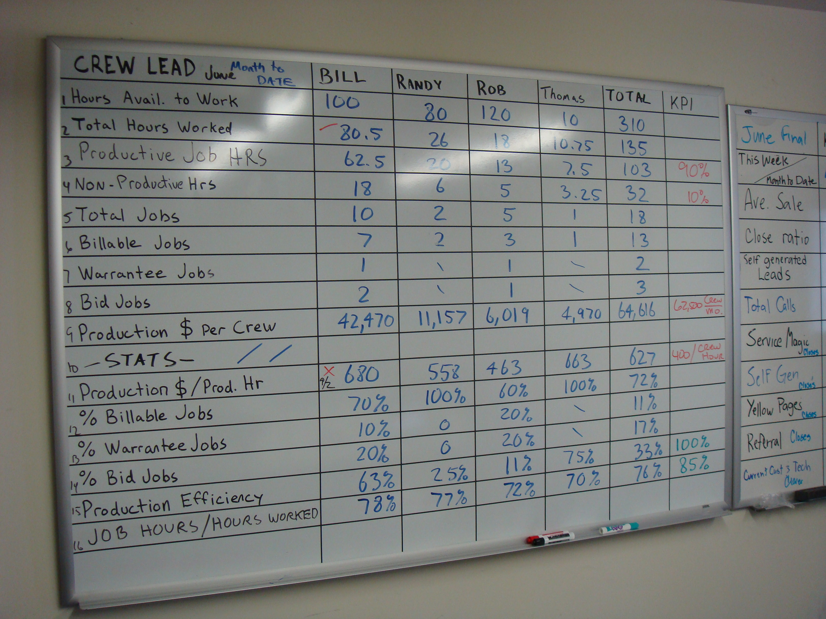
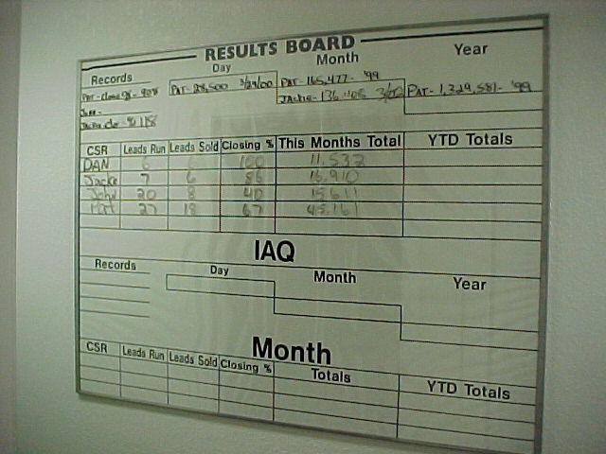
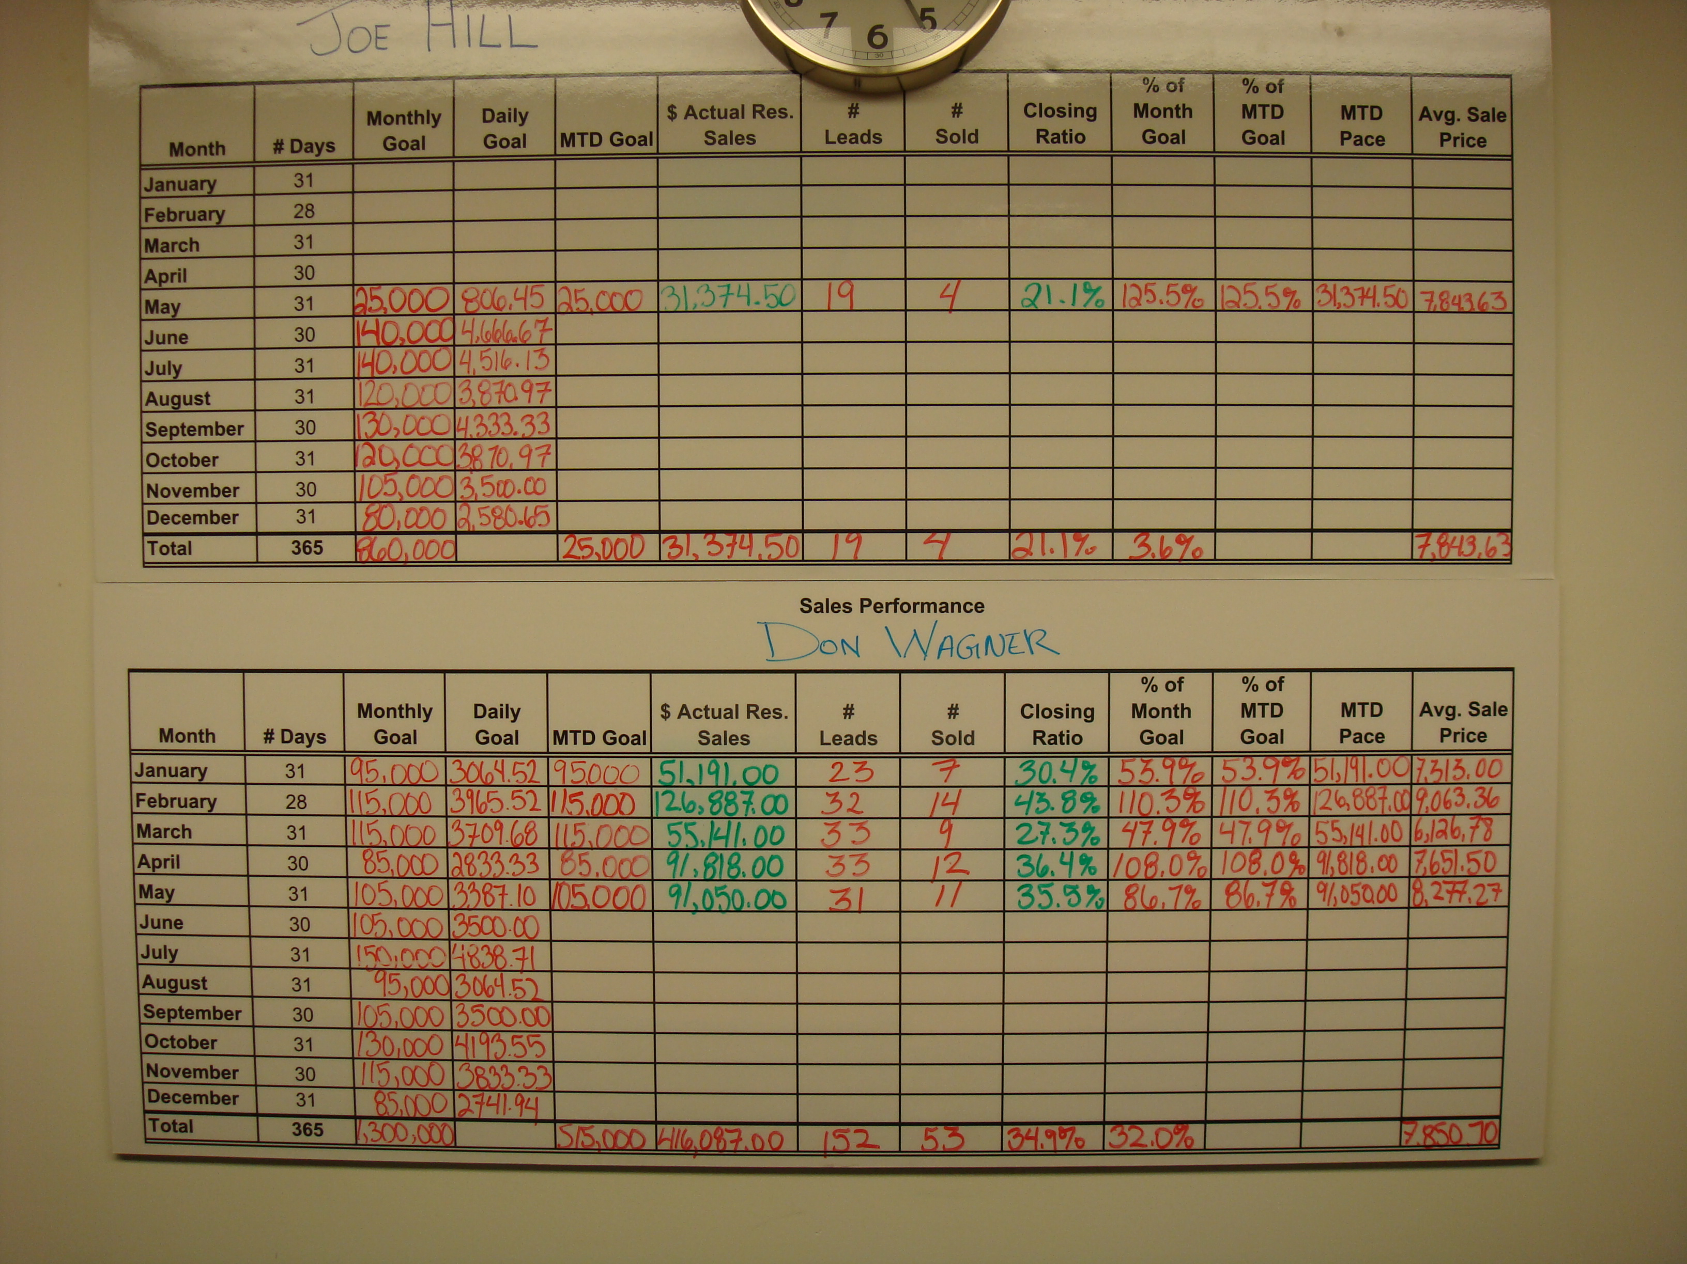

When using revenue as the means of measuring productivity and individual technician performance, it’s important to be fair in regards to how warranty work and callbacks are handled. If service technicians have to go on warranty calls, divide these calls among all the service technicians. Some companies even require the installation technician take care of the warranty problem if at all possible.
On callbacks, it’s advisable to send the same technician back to the call. The technician learns from his/her mistake and it’s fair to the other technicians in terms of revenue generation.
Revenue per W2 Wages
This is an interesting method of measuring technician productivity. Service management takes the revenue each technician produced and divides by the wages from their W2 forms. The higher the number, the better the productivity.
It’s quick and easy to calculate. Technicians understand the rating system and the importance of generating revenue in conjunction to the wages earned. Technician ratings can be published in a company newsletter or posted for all to see. Special contests or awards can be created for recognition. It once again is a means building technician accountability in regards to productivity.
If you use this type of method to track technician productivity, be sure to also communicate how the entire service department is performing to plan. This helps management focus attention to the group’s goal as well as individual technician performance. Special contests are bonuses can be tied to achieving the department goal. It can be fun and helps build teamwork.
Actual Repair Time Versus Time Allotted Comparisons
Some flat rate pricing systems integrate with the computer operating system and the flat rate pricing system to generate productivity measurements. If the computer system can monitor the actual time spent on the repair versus the time allotted for the repair, you should be able to generate a report that can quickly identify productivity problems. If your computer system has this capability, you should be able to see how the department is going as a total, how individual technicians are doing as a whole, as well as see what types of calls are causing problems.
Most dispatch systems allow you to time stamp when the call is dispatched, when the technician arrives at the call and when the technician completes the repair. With this information you should be able to generate a report that identifies dispatch times as well as the productivity reports mentioned in the preceding paragraph. Both types of reports should give you the information to analyze service department productivity.

Exploring Un-Billable Time Issues
Warranty Work
Warranty work for installations is usually performed by the service department. The accounting system should be set up with a warranty reserve account. As warranty work is done, funds should be taken out of the warranty reserve to compensate the service department for the repair. Accounting systems handle this in different ways. Some systems will pull the money out of the warranty reserve and treat it as income to the service department. Some companies charge regular street rates to the warranty reserve account so the service department does not subsidize the installation department.
Other systems will pull the money out of the warranty reserve and offset the labor expense in the service department cost of sales. There are tax considerations on how this is handled.
If a company does not have a warranty reserve the service department usually ends up eating the repair without any reimbursement.
If a company does not have a warranty reserve account or money is taken to offset only the cost of labor, labor sales revenue is affected. In all cases, the service department loses part sales, which also affects overall revenue.
Callbacks
This is a situation where a technician did not complete the call on the first visit or the technician did not solve the problem and another call was generated to fix the problem. There’s a Key Performance Indicator in regards to ‘first time’ completes. It says that technicians should be able to complete the service call 90% of the time. To determine your first time completes, divide the number of callbacks by the number of service calls and then subtract from 1. For example if a company generated 580 callbacks out of 5,800 calls during the year, the first time complete ratio is:
580
5,800 = 10%

1 - 10% = 90% First Time Completes

Incidentally, most callbacks under this scenario should be caused by the need to order a special part. Callbacks caused by not solving the problem correctly, should never be an accepted as a part of doing business and must be managed carefully to avoid problems in the future.

Travel Time
Travel Time is a major issue that impacts productivity for most companies. The pricing system should incorporate travel time into the service charge. Yet for many companies, travel eats up more time than what’s allotted for in the pricing system. The cause is usually inefficient dispatch practices. Here are a few examples:
- Not dispatching technicians to the first call of the day.
- Not dispatching calls one at a time.
- Not dispatching to the skill level of the technician.
- Not dispatching to a tight geography.
- Not having a working knowledge of acceptable repair times.
- Technicians not communicating with the dispatcher to let him/her know the status of the service call.
- Not time stamping correctly in the dispatch system so management can run meaningful dispatch reports to analyze travel time.
For more information on recommended dispatch practices that improve productivity, refer to other articles on the website including:
- Step by Step to Service Dispatching Procedures
- Service Department Operations – Reducing Labor Cost to 22% of Service Sales or Less
Other issues that can affect travel time include:
- Poor truck replenishment practices.
- Callbacks

Why is this Critical to Your Success?
Being able to measure and manage service department productivity:
- Allows you to see how the service department is performing compared to its potential.
- Allows you to monitor the service department productivity.
- Allows you to monitor individual technician productivity.
- Allows you to understand the issues that impact service department productivity.
- Allows you to gage progress as you implement a plan to improve service department productivity.
Productive technicians will help the service department attain several Key Performance Indicators including:
- Keeping labor costs in demand service sales to 22% or less of labor revenue.
- Achieving $125,000 or more in service revenue per service vehicle.

